INTERVIEWS.

1. 1.    The Climate Optimist, an interview with Terry Taminnen, The World’s One-Man Climate Fixer.
2. 2.   The Nature Activist, - or why you should care about the Amazon, an interview with Igor Botelho Bernardes

3.   The Politician: An interview with Hon. James Shaw, New Zealand’s former Minister of Climate Change in the Jacinda Arden’s Government.

## General principles when thinking about roles - Jason Yip - Medium

# Interviews

## The Climate Optimist.

An interview with Terry Tamminen, The World’s One-Man Climate Fixer.

Tamminen’s career has taken him from founding the Santa Monica Bay Keeper to being California Governor’s Arnold Schwarzenegger’s Chief Policy Advisor, crafting policies that put California at the forefront of environmental action.

In 2007, Tamminen founded 7th Generation Advisors, a nonprofit that empowers organizations to adopt solutions that fight climate change.

Tamminen served as CEO of the Leonardo DiCaprio Foundation, where he oversaw all operations and environmental initiatives.

An accomplished author, Tamminen has published multiple books on environmental topics, including carbon emissions.

In 2008, The Guardian ranked Tamminen #1 in its “Top 50 People Who Can Save the Planet.” Tamminen was named Vanity Fair's May 2007 Environmental Hero.

He is currently CEO of AltaSea, a unique public-private ocean institute that joins together the best and brightest in exploration, science, business, and education.

**We’ve been a long way from your early days as an ocean activist to what you've achieved as California Chief Policy Officer under the government of Arnold Schwarzenegger, and where the market is now - ready to embrace your ideas and to put them into action. Please, tell us about that journey.**

Yeah, it's an interesting journey. I do a lot of work on hydrogen and using hydrogen to help decarbonize goods, movement, and shipping. And I started a nonprofit to work on those things in 2000. So 23 years ago it was called Energy Independence. And everybody thought we were crazy. Hydrogen can never do it. It's all about battery, cars, batteries, batteries. Well, now, of course, we're finding out that batteries take a long time to charge. They take precious minerals that children in the Congo are digging up out of the Earth for us. It takes a lot of electrons if you're going to charge all of those cars, not to mention trucks and other heavy-duty things. So really, the only way we're ever going to electrify everything is with some battery but some hydrogen electric.

And so now, because of the federal government and the Hydrogen Hub Initiative, suddenly everybody's discovering hydrogen. But like I said, we've been working on it for 23 years, and now it's a big overnight success.

**What we're trying to do is really share with people who don't have the chance and the history you’ve had, to work on the topic for so long, to understand the nuances and the journey and the innovation that we now see in climate action. For those who don't have that chance, how can they play their part?**

**Maybe we can play a game where we can say simply “if you run a small business with a dozen employee” and let's say “I am an accountant or a dentist or a doctor, then what should I do? What can I do now, by Friday. and why?**

Well, so the first thing is important to convey what you just said, which is that everyone can do their part.

And that look, some people might say any one contribution if I take my bike to work today instead of driving a car isn't going to make a difference to the planet. But obviously if a million people did that today and every day, it would make a huge difference.

So when you get everyone doing something, it does make a difference. And it doesn't have to be driving a Tesla. It could be something as simple as using public transportation or taking a bike to work instead of your car. It could be eating less meat, which is a huge driver of course, of climate change and obesity and all kinds of other things. So, it's good for the planet and it's good for you.

You can do things like just simple energy efficiency measures. By now most people have replaced old inefficient light bulbs with LEDs. But you could put some things in your home or your office on timers or light sensors so that they shut off when you leave the room and things like that. You can try to reduce your waste. That's another thing. I think waste is one of the biggest problems to our sustainable planet because if you think about it, every day we go around the globe to find a barrel of oil, then we move it around the world and we refine it with huge pollution and spills and so forth.

And then we put it in our car and we burn it or we turn it into plastic and then we throw away the plastic and then we this all over again. So if you could reduce waste, if you could reduce your use of single use plastics, for example, or just get away from plastic as much as possible, that's helping the planet.

We cut down forests for pulp and paper, and then we throw that away and some of it gets recycled, but not enough. So reducing our use of paper, I have to admit, for example, I used to get the Los Angeles Times and the New York Times delivered to my door every day. And I'm an old school guy. I love to open the paper and read it and turn it, et cetera.

But I realized what a huge impact that is on the planet for paper, for ink, for the heavy paper being delivered to my door, the fuel that it takes to do that, et cetera. So several years ago, I reluctantly gave up those subscriptions and I read everything online. And when you get used to it's much easier. So, reducing your subscriptions to things and going to digital if you haven't already.

There are a million things you can do, but the worst thing you can do is to take no action, to think it's someone else's problem.

**Now, let's continue this little game, Terry. Now, let's say that I am a municipal leader, a local leader, a council leader. Let's say that I have a political role in my region or in my community.**

**How should I approach that complicated topic, especially as we know that some of my constituents may understand or perceive climate action as either an impediment, a cost that they may not want to face, or a cabala of some sort that really isn't anything serious there.**

As you know, I'm a Democrat who worked for a Republican, Arnold Schwarzenegger. The way that we overcame the problem you just highlighted is by putting things in terms that everyone can understand. So, for example, if we want people to drive their cars or their trucks less, if we want to turn them over to electric, instead of talking about climate change, we talk about clean air. We talk about air pollution and disease. And that's something everybody understands, especially in California where we have so much smog and air pollution. And then if you're that small city council person or mayor, you can think about what are the ways I could save money for my city that would also be good for the planet.

When we were in government, we did a study about retro commissioning buildings. Not retrofitting, where you'd have to go through and change out the heating and air conditioning and the elevator motors and everything like that, but retro commissioning. Meaning? You go back through the building, and you imagine it's brand new. And this is the first time you're turning on your HVAC and your lighting and checking your door seals and your window operations and so on and so forth. And you tune up the building. You make sure that everything is working the way it should.

So we took 50 different buildings in the California government building system, and they were all different styles, everything from universities and classrooms to hospitals and so on. We did a retro commissioning study. The experts said that's a great idea, you'll get maybe 5% to 7% in energy savings. After two years the average energy saving was 18%. So just by going around and making sure that doors closed properly, windows weren't left open when the air conditioner was on, et cetera, just basic retro commissioning, we were able to cut the energy use by 18%. That saved money and was something we should have been doing all along anyway. Things like that.

To retrofit the Empire State Building, which for a time was the biggest building in New York, they wanted to retrofit aspects such as insulation and lighting and other minor things that you could get at. In fact, they didn't even change the whole heating and air conditioning systems. They only did things that had a three year payback from the savings, and they cut their energy use by 40%. Now, that's a very old building, but that shows you how simple it was. One example was, being such an old building, they had old radiators that sit right next to the wall. And they realized that because the building was mostly brick, half that energy was going through the brick wall and out into New York City. It wasn't coming back into the building. So one of the simple retrofits was they put heat reflectors between the wall and the radiator, so all the heat would come back into the building. So you could use less heat. I mean, duh. Retrofitting, retro commissioning and being if you're part of a city or any other kind of government, you control a lot of real estate.

You also can lead by example in terms of buying. So how many cities you walk into their mayor's office, and they've got a conference table, or you walk into the city councilman's office and there's a bunch of plastic water bottles on the table. Ban single use plastic, at least in your own city, in your own government. Buy more fuel-efficient vehicles for your city fleet, including electric, if you can, et cetera.

And I guarantee you that if you go through and look for all those opportunities to do things that save money while they're helping the environment, you can convince anybody that it was worth doing.

**I'm going to continue on that game and I'm going to apply it to a category of people which is important to New Zealand, the farmers. Because, as you know, New Zealand economy relies very much so on its dairy industry. New Zealand is one of the top dairy product exporters in the world. And so here we go on the difficult challenge of removing methane emissions from the farming sector here in New Zealand. So let's put on the hat of the farmer and let's talk about the value chain from the production of food into the consumption of food. if I am a farmer, if I am in this industry, what can I do now without feeling that my subsistence, the very core of my activity, is threatened because I'm being asked to take action?**

Twelve or 15 years ago, I was in New Zealand visiting Helen Clark, who was your prime minister at the time. She was telling me how a lot of what we were trying to do in California, where we’re capturing methane from confined feedlots and animal waste and turning that into biofuel wasn’t doable in New Zealand because the animals roam on open pastures, where they fertilize the land. And obviously, you can't control their emissions. But she told me that the university in Christchurch was doing extensive research back in those days. It was new.

Many are looking for different diets that reduce ruminant methane emissions. And the number one source of a diet that is healthy for the animal and reduces methane is kelp seaweed. And so here at AltaSea [where Terry Tamminen is CEO], we've got researchers breeding different kinds of kelp and feeding it to animals in different formulations to see how much it reduces their methane. It does it dramatically, as much as 90%. Now, when you give and the protein and the nutrients in kelp are so rich, it's a much better diet than what these animals are being fed today, soybeans and other things which take up a lot of land.

So you're reducing the carbon footprint by growing kelp in the ocean, letting the ocean provide the nutrients and then giving that to the animals. But they did experiments in universities here I know, where they gave that same feed to dairy cattle. And the dairy cattle, you could only go about 20% of their diet with kelp because after that, it changes the flavour of the milk. But if it's beef, if you're just going to eat the animal, it doesn't change it. And even 20% is 20% less impact on land for growing soybeans. It's 20% less methane, et cetera. And it's a very sustainable industry, which New Zealand has a very strong aquaculture industry, which we're learning from here. In fact, one of our companies, the main strategist is from New Zealand.

In terms of crops, we're learning a lot more about regenerative farming and ways to keep the carbon in the soil rather than the kind of typical farming which then also uses a lot of expensive chemical-based fertilizers. You can eliminate a lot of those if you work on regenerative farming techniques, which, again, I think are probably more aligned with New Zealand farmers than American industrial farmers. So might be an easier message.

**So now let's say I'm an investor looking for new opportunities. How would you advise me about what I can do to make money by being a smart investor in green technologies, green products, and services. What should I do?**

Well, the first thing I think most investors are most worried about is risk. When I was EPA secretary for Governor Schwarzenegger, businesses would come to me and say, oh, we don't want you to put that new rule on us. We don't want you to regulate this or tax that. But if you must do it, please give us time to prepare because we need certainty. So the number one thing business wants is certainty and time to prepare and avoid risk. Well, there's nothing more uncertain than the price of oil.

In the last five or ten years, the price of oil has gone from $150 a barrel to negative dollars a barrel during COVID and everything in between. And right now, with the situation in the Middle East, people are worried about it spiking again because the [war in Gaza] might interrupt global supplies. The war in Ukraine has interrupted global supplies of oil and gas. There's nothing more uncertain than the fossil fuel future, not only because of these supply chain interruptions, but because of climate change. As a result, more and more industries are trying to move away from fossil fuels. If I'm an investor, I want to look at the places where there's less risk and start moving my money there. Not just what am I putting it into, but what am I taking it out of.

I should be taking my money away from sectors and industries that are fossil fuel dependent, such as airlines, which are going to suffer financially from these price shocks, up and down or the availability or the lack of availability. And instead, maybe be investing in sustainable aviation fuel companies that are developing biofuels or hydrogen fuels or other solutions for the aviation industry because that's going to be more certain in the future, both because of regulation and because of the uncertainty of fossil fuels. I'd be looking at the companies that are evolving their own carbon strategy, reducing their own carbon footprint.

Just on the news today commentators were speculating that if the price of oil goes up because of the Middle East conflict, the number one industry that will be hurt will be food. And right now, because of climate change, with more uncertainty, with drought, with more wildfires, more floods and so forth, in our south and southeast Texas and Georgia, farmers were showing their peanut and soybean crops and their other crops devastated by 70 to 80%. Because of such a hot summer last year followed by no rain for eight or ten weeks, food is getting more expensive and production more unreliable.

And so investing in sustainable foods like sustainable seafood, various other kinds of more predictable types of feedstock for animals, for the whole supply chain is another place to be looking where most people wouldn't think about it. You think about this transition, and you think, oh, Tesla, electric cars, batteries, Led lights, solar panels, okay, that's all good. But as an investor, those investments have already run up. In fact, if it's Tesla, maybe they've run up too high and they're going to come back down at some point to reality. If you're looking for opportunities, you want to find the things that haven't been pushed up yet, but that are going to be part of this transition to a low carbon economy.

**If you reflect on some of these insights, it seems to require a lot of information and education across sectors. And so, if we think again about the everyday person that doesn't have the benefit of that exposure, how do we get up to speed? Where should we go and learn? How do we understand what's going on around us?**

Well, I think it really depends on how much time you have. Anybody that is serious about this and has time, thanks to the Internet, there's a lot of information out there. There's a lot of conferences. I just spoke this morning. The Financial Times of London is having a conference right now in the next two days on the energy transition. And I was on a panel, the very first panel of the day with other world leaders talking about this. You know, there's a lot of information out there in publications and webinars and conferences and so forth, if you have the time. If you don't, you can go to I mean, even here. Our bank of America, which is our largest bank here, has a no fossil fuels money market fund where they invest in companies that screen out anything to do with fossil fuels.

And it has outperformed our Standard and Poors and our Dow Jones and so forth for the last ten years. Many other fund managers have these kinds of fossil free. Increasingly, they're looking for things that are low carbon or more progressive so you can let somebody else do the research for you and just piggyback on those experts. {NDLR or use ChatGPT and other AI engines to accelerate your screening research].

**Very good. So I'm going to shift, and I think that little game is interesting to see because it shows us that really we all have an opportunity to participate and join the movement.**

**I'm going to ask you two more questions if you don't mind.**

**The first one is what made California such a leader on environmental action? Is there specific ingredients that you believe were the requirements that made it possible to see that leadership?**

You know, I think part of it is our climate. I mean, throughout the year people can go to the beach, they can go to the desert, they can go to the mountains and go skiing. Literally, within 2 hours of my home in Los Angeles, I can go skiing or I can go to the desert, or I can go to the beach. And so people are outdoors. There's also a fitness craze out here, you see people on roller skates and jogging, and all the fitness crazes start out here, in California. And people are concerned about their diet. They're concerned about their health and the health of the planet. Then it just is a natural thing to realize, well, wait a minute. We’re not just doing this to the planet. We're doing it to ourselves.

“The Guardian newspaper ranked me as the number one person who could save the planet, which is kind of a funny thing to say, but I'm not here to save the planet.” - Terry Tamminen

The planet will be fine without us. It will recover. It'll go on spinning. Nature will be better without us. But we're trying to save our own quality of life on this planet. And that's something that I think people in California really understand, because maybe because we kind of invented smog and air pollution. Literally, we invented the term smog and then the air quality board and government, which now regulates everything from tailpipes and cars to smokestacks in power plants and so forth. And that was initially, of course, for health, for air quality reasons.

But then we realized over time, one of the biggest things that's also coming out of those smokestacks, or those tailpipes are greenhouse gases. So it was logical to go to that. And I just think if you're raised here either as a Democrat or a Republican, this is just an issue you understand. And we kind of don't understand how the rest of the country doesn't get it.

“if you're raised here either as a Democrat or a Republican, this is just an issue you understand.” - Terry Tamminen

Yeah, that duh moment. That's right. When you touch that beauty of nature in any shape or form, it's very quick to show you that there is a better way, a more beautiful way, a more satisfying and fulfilling way.

And I can tell you that Arnold Schwarzenegger always tells this story that when he was a kid in Austria, he saw the pictures, the Hollywood celebrities on the beaches in Malibu, running on the beach. He wanted to come to California, not only because it was Hollywood and so on, but because he imagined this beautiful, pristine place. And he got here in 1968, when some of our air pollution was at its worst. I mean, some days in summer, the sky looked like melted cheese. And then he would run on the beach, and there would be trash and even syringes, needles and such there. And he couldn't believe how people could schmutz the planet this way.

And so he always, even though he was a bodybuilder and then a movie star, he always wanted to help the environment. Did it by donating to causes privately. But then when he wanted to become governor, the number one thing he wanted to do was to work on the environment. And as you saw, that's what he did. But it was all this image of this beautiful, healthy, clean, natural state, which then when you get here, the reality was different. And we all had to fight to improve it. And things are much better than they were in 68, and I think even better thanks to Arnold for so many of the things we've done. But it's all part of the culture.

**Congratulations for all of that. It is inspiring. Let's close one big question, which is, I've heard you speak about purpose and hope and optimism. And where you are today in your position that very day, do you take the optimistic route or do you stay still, sceptical that we can do it? Where are you sitting in the spectrum of hope?**

And you know, Winston Churchill said that Americans always do the right thing, but only after trying everything else first. And I think that's true when it comes to the environment and climate change, not just for Americans, but for the whole planet, we're destroying it at a record pace. But now we're starting to see the data. When our parents were our age or younger, they didn't have the data. They didn't have satellites, they didn't know how much was being destroyed in foreign countries or how much air pollution was coming out of the tailpipes of their cars, and there were fewer cars. But now our generation, we have all this information, we have all this data, and there's no reason that we can't make the changes necessary to have a sustainable planet.

When you ask if I'm optimistic, I'm sad for what has happened to the people who have already suffered, for whom it's too late. Whether that's victims of catastrophic storms that were much worse because of climate change or droughts, particularly in Africa and other places where people can't just go to the grocery store and buy a bottle of water or whatever. So for many people around the world, it's already too late. But for most of us and for the whole planet, it is not too late. We still have a chance to reduce our emissions. Right here at Alta Sea. We have three universities researching how to take carbon out of the ocean.

You've probably heard of direct air capture where they're pulling carbon out of the air. That's very inefficient because you must process so much air to get a little bit of carbon. But water is so much denser. And Seawater has absorbed one third of our carbon emissions lifetime since the Industrial Revolution. So there's plenty of excess carbon in the ocean. And now this technology is pulling it out much cheaper and more efficiently than direct air capture. And the byproduct is hydrogen. So you can put that hydrogen into ships and container handlers right here in the port and have a double benefit when.

I see things like that, and I realize the innovation that's happening and the progress that's making. Yes, we waited until the 11th hour, but I do think we can turn things around again, sadly too late that we didn't pay attention sooner, but the future is brighter.

“Winston Churchill said that Americans always do the right thing, but only after trying everything else first. And I think that's true when it comes to the environment and climate change” - Terry Tamminen

**That's wonderful. That's great to hear and inspiring and a bit recomforting because we understand that some young people go to climate anxiety and that it's causing either mental health issues or concerns for many of them. So, I think keeping a positive, upbeat and inspiring and a future where there are new possibilities is really important. And let's hope that we can all equip ourselves and learn from the sources and the experiences you mentioned, so that we can go and do the work we all need to do and play our part so that we can achieve what needs to be done. Now, with the message that the action needs to take place by Friday, which, as you know, is the title of that book.**

Well, Shakespeare says, Nature's bequest gives nothing but doth lend. And so when nature calls thee to be gone, what acceptable legacy canst thou leave.

If we act by Friday, even Shakespeare would be proud of that legacy.

**I think we'll be proud of ourselves for doing that. All right, Terry, listen, I can't thank you enough for that. I think this will give wonderful material and will fit very nicely in the book. I will keep the recording and we may decide if you agree to release it separately as one of the tools. As a follow up to the book, I will share with you the transcript and the outcome, because we will select and cut through to make it fit the format of the book. But again, I can't thank you enough. I will be in Europe next year and I will continue the journey and support whatever needs to be done at the industry level.**

**Here where we've done quite a bit at our scale and in our sort of field of activity around products, packaging, ingredients and so forth. We just signed the largest power purchase agreement with solar energy generation in New Zealand. We’re very happy with that, but there is so much more we can do.**

Fantastic. Thank you for the opportunity. I'll be happy to participate. Any other way I can promote this. Obviously, when it comes out you mentioned Walmart. I'll leave you with one little anecdote, which is something that any businessperson can do. So, years ago, when Walmart was just starting its sustainability journey, I was an advisor to them, and I went into the first meeting and what do you do? You hand out your business card? I hand out my great big business card and they hand me little half size cards like this. And I said to them, you're asking me for advice about sustainability? And Lee Scott, who was the CEO at the time, looks around the table and everyone kind of looked down. He said, we don't do it for sustainability, we do it because it's cheaper.

And since then, I've had these little half business cards. Now, even better if we use the QR code and we just let people take a picture of our information and we don't even use paper. But here's a simple step. You can order these online, I'm sure, even in New Zealand, and you can save paper and ink and processing. Right. By Friday.

**Here we go. By Friday. All right.**

## Why should we care about the Amazon?

**An interview with IGOR BOTELHO BERNARDES, Brazilian activist for the conservation of the Amazon, and entrepreneur dedicating his life to making Regenerative Economy our new reality.**

**Why should we care about the Amazon? Think for example about a mother who lives in Nelson, New Zealand, has three kids, and is struggling to make ends meet. It will be hard for her to have compassion for the fate of an Amazonian tribe that is losing its sense of direction because of how we are clearing out the trees** **of the Amazon. Even if compassion is ingrained in the human soul. So why should she care? Why should the person living in New Zealand, or Paris, London or New York care about what's happening in the Amazon?**

We should care. Yet the motivation is different. It could be by fear or it could be by love. Because we fear death and we fear the end of the world and we fear that climate change is going to destroy everything. Take fires: we fear that the fires like in Australia, California, Greece and Maui are getting more frequent and bigger. So we are afraid of dying. This is one simple motivation for caring. The other motivation is because we love. We love the planet, as we love others and love biodiversity. So for both motivations, the reason is the same. Because the motivation is something related to your emotions and your faith and all the contexts.

If you are at the bottom of the social pyramid, maybe you can't find motivation. For those who can't find the motivation, they’re trying to survive. The reason is the same. As the most extensive biodiversity forest in the world, the Amazon is the largest freshwater reservoir and the most important climate-regulating forest block on the planet. So doesn't matter the motivation. For the one living in Paris, the rain he sees is coming from the Amazon. It's called the Flying River.

The Amazon has so much water going to the sky, literally going to the sky, forming clouds. And these clouds travel the world and pour their rain everywhere. The Amazon is the biggest thermal regulator on the planet.

So if we achieve the dramatic point of having the first Amazon desert, the desertification of an area of the Amazon, then we're going to see suffering on an exponential scale. That's why I chose this battle. Because I want to regenerate the planet. I could choose taking plastics out of the ocean, saving the polar bears or whales or sharks. There are so many battles. Every battle matters.

The Sahara winds lift the hot sand from the Sahara. If there weren’t the Amazon rainforests to absorb these hot winds carrying sand from the Sahara, to transform that into water again which rains in Paris, we would live on a planet that can’t thermoregulate itself.

There is a beautiful poem by Titan Tan talking about what the clouds would say about the territories we are discussing. It says we are connected by water. Without the Amazon, there would be no cycle of water as we know it. There would be no connections.

There is no other biome like it on the planet. There's no other biome that influences the other biomes as the Amazon.

**What is humanity's relationship to the Amazon and why is that relationship so vital to us?**

We don't have a relation to a place as a collective without having a relation as an individual. So I'm just using my own case to say I'm an individual who has a strong relation with the biggest source of oxygen on the planet and the biggest source of biodiversity on the planet.

What is the Amazon? it's nine countries, it's seven states of my country. 28 million Brazilians live there in the Amazon, as a community, as a culture.

Human interaction did not destroy the Amazon. The Amazon rainforest was planted by humans, by nomadic people traveling and planting and co creating with nature their own way of living. The Amazon is a co creation between men and nature. It's thousands of years of work between men and nature and the design of that is perfect.

When you go there you see how the people from that culture live with the forest. You see it is completely doable to live with nature, not live from nature. When we live from nature, we are just extracting resources and industrializing those resources into other things that have profitability.

When we are talking about the vision of the indigenous bioeconomy, this is the interaction between how human interaction with the natural capital can create something that is sustainable for all the species, not sustainable only for the human species.

We are trying to shape what the bioeconomy of the Amazon can be. A bioeconomy where we focus on resources and commodities and transform that into industrialisation. Therefore we have capital to feed the capitalism cycle that we know. This is what was done with rubber and then wood and then cows and then soil and then whatever.

There are at least three new patents from the Amazon every day being discovered from pharmaceutical companies in the US, Germany, Japan, and other countries. So the idea of extraction and transforming to add value, which is another very dangerous word, a word that implies that a tree has no value until you make a a is for us like the spiritual connection between the Earth and the universe. So I lose my spiritual connection with my ancestors.

Natural capital is something like a resource. It has no added value. Once we transform that into something, once we transform the rubber into Nike shoes, something, then it will have value.

And that's what I've most learned from them, that we need to learn again how to be nature.

This is not for everyone, but this is what natural means.

**What can the reader of this interview or this book do about it?**

A friend of mine who is a yoga teacher always says ignorance is a blessing. Once you know about a problem, you can’t unknow it anymore.

Once you know about the problem with the Amazon deforestation and its impact on our biosphere, you can find ways of supporting it. For example you can stop consuming the products that are consuming the Amazon.

You can start talking about your conscious incoherences. This is the terminology that I'm using.

So am I building a home? Can I buy wood that is certified, that is not coming from a rainforest? Am I a consumer of something that comes with rubber? Can I certify that this rubber from the Nike or Adidas I wear is a recycled rubber?

So as a consumer you can start researching the resources used in everything you consume.

I don't eat tofu that is not organic because I know that 99% of Brazilian soy production is not organic. So I know that any organic tofu is not coming from the Amazon. So it's already a way of knowing. But I also look where is this soy coming from.

This is about coherent consumption. Like how do you consume for the planet, not consume for yourself.

This is beyond conscious consumerism. Conscious consumerism is when you get to know about the problem. Coherent consumption is when you buy or don't buy things because you are supporting a cause.

**What can we do by Friday:**

Challenge your conscious incoherence, and "Walk as if you are kissing the Earth with your feet.", as the poet Thich Nhat Hanh wrote in “Peace Is Every Step: The Path of Mindfulness in Everyday Life”.

**What we should know:**

A study published in 2013 in the journal "Science" estimated that there are approximately 390 billion individual trees in the Amazon basin, representing over 16,000 species.

**References:**

[Antonio Donato Nobre: The magic of the Amazon: A river that flows invisibly all around us](https://www.youtube.com/watch?v=CIesJyZUWTY)

<https://www.majesticsamauma.com/>

Joseph Michael

https://www.ethik.co.nz/work/amazonraisedupsky

<https://brasil.mapbiomas.org/en/>

## The Politician: An interview with Hon. James Shaw, New Zealand’s former Minister of Climate Change in the Jacinda Arden’s government.

Hon. James Shaw is a New Zealand Green MP, former Minister of Climate Change and Green Co-leader. James was appointed Minister for Climate Change, Statistics and Associate Minister for Finance in the Jacinda Ardern Government in 2017.

His first term successes include the passing of the historic Climate Change Response (Zero Carbon) Act, reforming the Emissions Trading Scheme and establishing Green Investment Finance, a Crown-owned commercial fund to accelerate investment in the low-carbon economy.

In his second term, James was appointed Minister for Climate Change and Associate Minister for the Environment (Biodiversity) and launched a suite of measures to protect our native biodiversity.

On James’ watch, New Zealand’s total pollution into the atmosphere reduced in 2020 and 2021 and is projected to continue to decline for 2022.

James grew up in Wellington's Aro Valley and attended Wellington High School and Victoria University, before moving to London, where he lived from 1998 to 2010, to begin a career in management consulting at PwC.

He moved back to New Zealand to run for Parliament in 2010 and was elected in 2014, becoming Green Party Co-leader in 2015.

**Hi James. I’d like to ask you to give us a short description of your experience as a politician, as someone who's been pushing the climate agenda alone against an entire political system for which the topic could be important or less important, but for sure for which Climate is not the topic of all topics. What's been your experience driving this, carrying that topic on your shoulders as a myth of Sisyphus going up the hill? Please tell us.**

Yeah, I'm probably going to need to write a book of my own just to process the experience. So the short version is that it was the best job I will ever have and the hardest by several orders of magnitude. And there was a lot of the time when it wasn't fun, but the privilege of knowing that were making a significant difference of real scale made it all worthwhile. I worked pretty hard in 2020, in 2023, to get another term. And If I'd had the option, I would have done another term. But I'm also aware that I was frustrated, angry, tired, not terribly pleasant to be around much of the time. There was a significant cost, and I was aware of that and I was burning through people because it's hard and I'm pushing hard.

And people loved it. They came on board, but they were turning over in the sense of just could not sustain it. So it was the best job I'll ever have and the hardest I'll ever have, probably. There was a lot of stuff that I didn't get done or a lot of things that didn't turn out the way that I wanted them to. But we did get some really big stuff done, and as you say, actually world leading stuff. And I think that's because I basically stuck to my lane. I knew what I wanted. I stuck to my lane, and I just kept doing it until I couldn't, until I ran out of runway.

And I think in politics, there's a lot of people who don't actually know why they're here. Someone shoulder taps them and says, hey, you seem like a likely lad. Do you want to stand for our party? And they're like, oh, yeah, no, that sounds amazing. And then they hear and they're like, okay, now what? The problems of the country and of the world are many. And for people like me who really like problem solving, you can get very busy doing a thousand things, but end up making very little difference at all because you scatter your attention away. So there was a lot of areas of public policy I would have loved to have gone and done some stuff in, but that would have distracted from the climate mission. And so I just had to kind of do that and trust that my colleagues were getting on with their parts of the jigsaw puzzle, even when I knew that they weren't right.

 You sort of have to trust that they're doing their job, even though you're fully aware that some of them aren't. You just have to kind of live with that. You can't be responsible for everything. So, yeah, top line. That's been my experience.

**In the way you describe your experience, there is lots of advice that other politicians doing a similar job could apply. Thank you for this. You spoke about the world leading sort of achievements or developments that you've been able to push here. Could you specifically call out two or three of them so that the reader can understand what they are specifically?**

  Yeah, well, some of these are things that I inherited. So we are one of, if not the first country in the world to have an emissions trading scheme. {Editor’s note: The New Zealand ETS was officially launched in 2008, making it one of the first national schemes in the world after the United Kingdoms in 2002 and the European Union in 2008]. Now, for most of its life, it didn't work. But one of the things that I did was I fixed it mostly. There's still a lot of problems with it, but I kind of set it on the right path. So I'm very proud of that. The most significant thing that we did, though, was the zero Carbon act.

  Our legislation was modelled on the UK's legislation, which came in about ten years before ours. In that sense, the UK beat us by a decade. But ours was the first, I think, post Paris agreement, domestic legislation, to put the Paris agreement targets into law. So, the 1.5 degree threshold is the purpose of the legislation, and everything kind of cascades down from that. Not perfectly right. There are a lot of flaws with that legislation, structural changes that some other poor soul is going to have to deal with at some point. But that shifted the context in the country enormously. Like hugely, in the same way that the Paris agreement, you could drive a truck through it, right? It's full of holes.

 But in signing the agreement and making the agreement, the whole world economy, the signalling effect was enormous. And the change since Paris has far exceeded the actual agreement itself. And the third bit that I'm really proud know after the Zero Carbon act, after the ETS reforms, was the climate disclosures, climate related financial disclosures regime, which I did the policy and background work on, but was actually led by the Honourable David Clark because he was the Minister of Consumer Affairs. Well, it was actually Chris Farfoy and then David Clark because they were the Ministers of Consumer Affairs because it's shareholder protection legislation. At least that's the camouflage for it. So they drove their department to do the policy work and so on and so forth.

 And I was sort of sponsoring, if you like, and I think the impact of that legislation has been incredible in quite a short period of time.

**Can you please explain in layman’s term what it means, what was the impact of this legislation?**

 So it actually started in Paris, where I was an observer, and I meandered along and sat in the back of the room at the launch of the task force on climate related financial disclosures with Michael Bloomberg and Mark Carney. And these are two pretty dry individuals, right? They're not kind of crazy hippies, but the language that they were using in very dry terms was incredibly stark. I remember Mark Carney saying that there are literally trillions of dollars of unquantified, undisclosed and unmanaged risk sitting on corporate balance sheets to a scale that actually represents a threat to the financial system at large, not just to those corporates and to their shareholder interests.

 So they were promoting the system of essentially requiring companies to report on those climate related risks to their boards and to their shareholders as a way of kind of therefore reducing that risk. And so I kind of parked that in the back of my brain and then a couple of years later, when I became the climate change minister, I thought, well, we should have a crack at doing something about that. So our domestic legislation requires our largest banks, pension funds, insurance companies, basically the big asset managers and your largest publicly listed companies to report on financial, on climate related risks to that company and to report those to their shareholders in a public sense. And you can only go, it's pretty innocuous, right, because it's just reporting, so who really cares?

 But as the banks, for example, have become more aware of the scale of climate related risk, for example, to the agricultural sector, where they loan enormous amounts of their book with farms around the country or in housing, when you realize that we've got 74,000 houses that are exposed to sea level rise, inundation risk, flood risk, and so on and so forth, all of those mortgages then become at risk. The insurance companies are looking at withdrawing insurance services. Those organizations are now having conversations with their clients, right? So I know that there are rural banking managers who are talking to farms about how to reduce their emissions on the one hand, and how to make them more resilient to flood, fire, drought, storms and so on. And there are banks that are offering mortgage holders and households interest free loans.

 Keep in mind that we're in a high interest environment right now. They're offering interest free loans to retrofit their houses, to be kind of more energy efficient, to put solar panels on the roof, to put batteries in, to get rid of their gas stoves and replace them with an induction hob, all of that kind of stuff. And so whilst you kind of go, a reporting requirement for a bank seems really innocuous, but it's led into very significant changes.

**What you are describing requires a coordination of a million pieces, all working toward the transformation. What is your perspective, your hopefulness, your feelings about the likeliness that the system is actually moving in the right direction, that the pieces, one after the other, are all gearing toward the new model? How do you see that happening?**

Well, that's probably my greatest frustration with government. It was just how hard it is to get system wide action or focus. So we kind of forced it in the zero carbon act. We said that, well, the government will be legally required to have an emissions reduction plan and that means energy, transport, agriculture, waste building and construction, those are the sectors. And then you've got the kind of horizontals like the innovation system, science, research, technology, the finance system and all the work that treasury does, fiscal policy, and so forth. And what that meant was we needed those ministers who are responsible for those agencies to be given responsibility for developing plans with their agencies.

 And of course, those ministers all have their own priorities and their own ambitions and limited budgets, and their agencies are, most of them are like, well, we don't need to worry about climate change. Ministry for the Environment's taking care of that. Right? That's not really our department. And so the effort that went to and the prime minister took a huge amount of responsibility for this and she had to, because it required prime ministerial direction, to get a dozen ministers and kind of 20 different ministries to pull finger, assign some resource, get some people developing policy and make some commitments that could go into our emissions reduction plan. It was a huge effort and it is one of the things that actually people in the public service have said that they've never seen anything like it in their entire careers in the public service.

 And at best we nudged the system, and it was so uneven. So my golden child actually was the Ministry of Transport, because they'd started a couple of years before on their own, internal climate policy. They'd done a huge amount of work, they'd done public consultations, they had a 250-page plan. And when we said, well, we need a chapter on transport in our emissions reduction plan, can you give us something? They sent us the 250-page document and we said, this is amazing, it's fantastic, but can you cut it down by 90% please, or more? And they did. But then we had ministry for primary industries gave us half an A4 page of bullet points and even that took them three months to develop. And we sent it back and said, this is a joke.

 And we sent the transport plan and said here's the golden standard, give us that please, for agriculture. And they were resistant. So you kind of had those. But then that's just two examples. We had like two dozen agencies kind of working on this and most of them didn't have the resource to do it and they didn't have the expertise to do it. They were learning on the job.

**So just to build on that and as you're describing these roadmaps or these work plans to transition by sector, how do you in government deal with either the lack of data or the lack of specifics and the complexity around the certainty or uncertainty of how the economy and the environment may play out? How do we deal with the probability element of the work we're doing on climate?**

 Yeah, well, government's not very good at dealing with uncertainty, and yet that's the world that we live in, right? It's funny, when I was a management consultant, I spent a lot of time kind of working around the world of complex adaptive, self-adaptive systems. And government is not one, right? Like government is a command control machine or set of machines. But my view on it was if we could get started, then it would start to learn. The machine would start to learn because the people, the public servants who were grappling with it would simply get some personal experience. And if they hung around for a while, as new challenges emerge and as the data changes and so on and so forth, it could become more responsive than it currently is.

 But I don't think I ever believed that we could force it to deal with uncertainty because it's just not its nature.

**I think your answer here is very strong because it's building the muscle to adapt to external input that we are building as we go, as the science develop, as our technology or AI now coming in play, and now the data gets better and better, and as the data gets better and better, because we've built muscle before, we can become more agile and proactive in responding and adjusting our transition plans, adaptation mitigation and so forth. So there is something really valuable here, having prepared organizations and people in understanding and adjusting and dealing with that new reality, whatever the exact data output may be or not be there yet.**

 There are things, especially in the adaptation side, where scenario thinking is fairly core to the whole adaptation policy. People are getting better and better at the idea of thinking “Okay, so there are some long-term scenarios that we need to plan for. What's our risk appetite?” Those are not things that come naturally, I think, in any part of the public service. I was talking last night actually with the new climate change minister, and he said, well, as you know, this is pretty much the only portfolio, ministerial portfolio, where you're not thinking of the three year cycle, you're thinking of the 30 year cycle, right?

 And you're trying to work out what do in the three-year cycle that's going to have some success within 30 years, virtually everybody else is like, what am I doing today that's going to make a difference tomorrow? It's a very short cycle. So in some ways, the contribution of the climate change portfolio to the system of government is long term thinking. Kind of getting people's kind of out of the here and now kind of thinking. Well, actually, it is very here and now because the work is so, there's so much to do, but nothing that you do has an immediate payoff.

**I have two questions to respond to that. The first one is obviously, as the title of the book is, what can we do by Friday? Hold on before answering that, because, in fact, the real question that I think is interesting here, you spoke about the three world leading developments, but what are the next two or three things that the country should focus on to have that long lasting effect and still understand short term benefits?**

 Yeah. So in New Zealand, at least, adaptation policy is always the poor cousin to mitigation policy. But after last year's catastrophic floods and Cyclone Gabriel, I think people in the general public, but also in government, finally woke up, know this is it. This is not something that's happening in the future. It's happening here and now. An adaptation policy is starting to kind of move up the priority list. We need the equivalent of the Zero Carbon act, but for adaptation. So I think one of the next big challenges for climate policy is to do some pretty big, pretty brave high level framework, long term institution building. So that would be one priority. The next one, which is back on mitigation, is we've only got five years left to achieve our nationally determined contribution, and we're a long way short.

 And so we need to focus on delivery, some of which does require some legislative change to enable that delivery. So there is a bit of tweaking of things that have to happen inside the emissions trading scheme or other parts of the regulatory environment, the voluntary carbon market, and so forth, to enable this. But because we're so short of time and so far away from hitting the goal, we have to innovate like crazy and we have to break the usual way that we do government, which is to kind of stroke our chins and consult each other ten times and kind of consider all of the risks and so on. So by the time we finish that, it'll be 2030 and it'll be over.

 We have to run at this thing with a skunk works team composed of public and private and non-government actors together, but not like a 10,000 person deliberative democracy exercise, but like a team of seven who are just kind of smashed through this, who are empowered by the prime minister to kind of solve a very big problem. And I think that is possible. I think it's an incredibly exciting challenge. Part of is to kind of go, because in New Zealand, one of the things that's held us back is the idea that action on climate change is a sunk cost rather than an investment.

 So we believe that every dollar that we spent will have zero return, economic return. But actually, hitting the nationally determined contribution should be seen as the biggest investment opportunity that the country's had in a generation. Right. It could be phenomenal, and its outputs is New Zealand investing in the rest of the world, because we're not going to be able to do 150,000,000 tons [of carbon emissions reduction] all at home, but we can do a lot of it at home. So that's the second big one.

I think there's a third piece which is actually coming back to the zero Carbon act and some of the long-term goals, targets, accounting systems and stuff, because this is quite badly confused. And because it's confused, it's causing blockages in the rest of the system.

 And so for me that's a tidy up and a clarification in order to settle some arguments that we keep going around in circles on which are getting in the way of actual action on climate change. So that doesn't sound terribly exciting, but I think it's important that we do it because it's causing inaction.

**So you spoke about three things, adaptation, policy, innovate like crazy and fixing or improving the zero Carbon act. To clarify, can you talk to us about what can we do by Friday, not as a politician, but either as an executive, in relation to what you're describing as a political system, as an executive, and then as a simple person, as you and I being citizens of the world and citizens of a country. Let's start briefly with as an executive, what would you be recommending as your focus by Friday?**

 By Friday, I would say decide on Monday morning to electrify the company vehicle fleets and require a plan by Friday. Sure. Not because electrifying the fleet will make the biggest difference to your emissions profile, unless you're a trucking firm, in which case it is your emissions profile. But for most businesses, it's not the biggest part. But if you said, look, I've got a company, and in the basement, I've got 15 company car parks, and I've got 100 employees who drive to work, and they get parking buildings nearby. And I’d said, okay, well, we're going to switch to electric cars, then what has to happen is you've got to work out an asset replacement program for your existing ICE fleet.

  But most importantly, you've got to work out how to rewire your building to install charges with enough power that's not going to switch off the city block, cause a blackout on your city block and so forth. And then you've got to work with the drivers of your new cars. You've got to retrain them so they're like, okay, I come to work, I plug in all of that kind of stuff, right? And then you kind of think, oh, well, we're going to need more power, so maybe we need solar panels on the roof or some sort of supplementary energy to feed them, so on. So that project actually trains a whole bunch of people in your organization about what decarbonization is.

  And if it was the first thing that you did, regardless of the actual impact it has on emissions, which will be tiny, you suddenly have a whole cohort of people who have gone through the first-person experience of having to work something like this out. And then you can work with those people and go, okay, now let's look at the company's emissions profile. Well, we're a fertilizer manufacturer, so most of our emissions come from that. Now let's take what we've learned about rewiring our basement and replacing our fleet and apply that to the big industrial problem that we have on our hands here..

 And now they will do a much better job of it than if you'd said to them on day one, well, let's start with the biggest problem that we've got, because no one's got any idea what they're doing.

**I love that example. And I'll take it even to a smaller element than the cars. I'll talk about the disposable, removing disposable coffee cups from a cafeteria. Just find a way touch people in their daily routine in a way that starts a conversation. The example of the EV fleet is also excellent because the change management that it requires and the habits, the routine of how you park and how long and when and how you plan your journey and your trip is very different. And you're right. And it will prepare the organization at large, thousands of people, to actually move to the bigger rocks.**

So one of the first things that we did when we got into government in 2017 is just that. When you're a minister, you've got the crown fleet, right? The limousines that drive around, and we've got sort of 20 to 30 of those vehicles between Walton, Wellington and a couple of other places. And those are limousines, right? And so she said to the VIP fleet, I want to switch that to electrics as fast as possible. There's no high-end limousine on the market that's fully electric. At least there wasn't. But the fleet manager went around BMW, Jaguar, et cetera, and said, what do you got? And they said, well, who's asking? And they said, well, the New Zealand government. And they said, well, how many do you want? He said, well, 20 to 30.

 And they said, come back in two years and we'll have one for you. So even though it's a small number of vehicles, they're like, well, we want Jaguar. We want the New Zealand government to be driving our electric, because every time then the president of China comes to visit New Zealand, he's driving around one of them. So there's that. But more importantly, every minister gets a company car, right? So just like a standard company car thing. So it's a self-drive at home, but it's owned by the VIP fleet services. She [Jacinda Arden] said every minister has to drive in electric. And if you want an exception, you have to ask the minister for ministerial resources, which is the prime minister, and my answer will be no. And so two things happened. VIP fleet services had to suddenly go, oh, shit, what have we got?

 But it changed the business model, right? Because all of their internal economics for how to run a company car fleet were built around the ICE model. So they had to change the actual leasing model and all of that kind of stuff. And they had to do that very quickly because all of us incoming ministers are like, I'd like my car now, please. And then they had to go out and they had to cost and they had to source the vehicles. So they kind of scrambled and they did a great job and we all ended up with electrics and then they had to rewire the basement of the beehive. So that we could plug them in. And that is a big hard problem because beehive was built in. The previous building was built in like 1920 or something, what was not set up for it.

 So they had to install substations and cables and so forth. Going through that experience, there's 25 ministers. So the impact of that is infinitesimal. At the same time, we started to set up something called the carbon neutral government program. We said, we want the whole government sector to be carbon neutral from 2025 and so on. And so we started requiring all of our agencies to start the switch to electric vehicles. No one had any idea what they were doing.

 But the VIP fleet manager suddenly became the hottest property in the public service, and he was going around all of the other agencies telling the story of how we flipped the minister's VIP fleet, which was only 25 vehicles, over to electrics and what it required for rewiring, what the economics of it are and so on and so forth. So just that one project for a tiny group of people at the top of the organization filtered through the entire public service. And went through, we started getting better fleet management systems in place. Department of Health, turns out they had all these vehicles, half of which had never even been driven. They were just sitting in basements. So there was all these kind of flowing effects that happened just from that one thing.

**It's a powerful story, James, powerful story, and a great example of what we can do by Friday for executives. I'm going to ask you one last question before we close. Why New Zealand has this appetite or this position? Why is New Zealand so special?**

  I was doing my postgrad at Bath University, and I've been in sustainability consulting for a while, and I was doing some good work, doing some not good work, but mostly good work. And during the course of my postgrad, I had my nose rubbed in all the data around climate change. And I kind of had that crisis moment of thinking, shit, I really need to scale up my impact. Where do I do that? Well, clearly the political domain is where you get the most scale. And then, because I'm also a British citizen, I was like, well, do I do that in Britain or do It in New Zealand?

 Britain at that time, one of the largest economies in the world. But the British political system was so sclerotic. If you want to kind of make a real difference there, it's like, well, you got to decide when you're 13, you got to go to the right university, you got to become president of the debating union, you got to then go and work in some backbench MP's office for a while, then you got to go take a bullet for the party in some unwinnable seat somewhere and then maybe get a safe seat. And then you're at the bottom of the ladder in parliament. I thought, we don't have that kind of time.

 Climate change is going to take 20 years, 30 years for me to make any kind of real difference there. Whereas New Zealand is a much more open system because it's small and it does have a much more open political system and it has demonstration value. So we're not the biggest economy in the world, but we are an OECD economy. And because we're small, when an innovation takes hold in New Zealand, which doesn't happen all that often, but when it does, it sweeps through the entire country incredibly quickly. And so, you can actually change a whole economy really quickly sometimes when we choose to do it.

 And so what I said is, I'm going to go home, I'm going to go to New Zealand, I'm going to run for parliament there, and I want to get New Zealand to be one of the leading countries in the world in the fight against climate change, not because we will make the biggest difference with an emissions profile of less than 1% of the global total, but because the demonstration value of an OECD country going, yes, we're at net zero, the flow and effect of that, just like the EVs in the base, could be really significant.

**Well, I compare your answer to what I heard from Terry Tamminen. So, Terry, having had influence on the largest economy in the world, and you having the influence and making the choice, a strategic choice, to drive change in one of the smallest economy in the world, and yet have that demonstration effect, and I think it's really interesting to bring them both together because they both play a very powerful role in transforming our global economy to the right outcome.**

 Yeah, I agree. And actually when I made that decision, the UK was ten years ahead of us. We borrowed the Zero Carbon act from the UK. So I am not saying that the UK can't make an impact. It really clearly has done so and can do so again in the future. It was the strategic choice for me, speed, if I want to do speed and scale of impact. The pathway for me was not the UK.

**Very good. Brilliant. Thank you so much for all these great insights on how you've been able to drive the change you did here. There's a lot there's a lot of really great material. It will add a really nice component into the book.**

**I will let you know. I will share with you the transcript and how it's coming up. We're going to shorten it to make it fit into a shorter form and then I'll let you know what's going on over there in the UK. Because even if you decided to stay here, I'm sure there's always a chance to continue the conversation. And I really hope on my end that I can do the job of promoting New Zealand on the global stage a little bit.**

 I think it's worth mean it'll take you a little while, obviously, to get yourself settled. I know you're about to go through quite a big personal transition and so am I. So once you have your feet under the desk, do give me a will and if there's anything I can do, let me know.

**Note:**

This book proposal and any attachments are the sole copyright of Tony Balfour and David Benattar and are sent to you in confidence. They may not be copied, distributed or their contents divulged without our prior written consent. If you are not the intended recipient, please immediately notify us and destroy any copies. Thank you.

## 10 Charts to Orient Ourselves.

1. Global Temperature Rise 1900-2020

# 

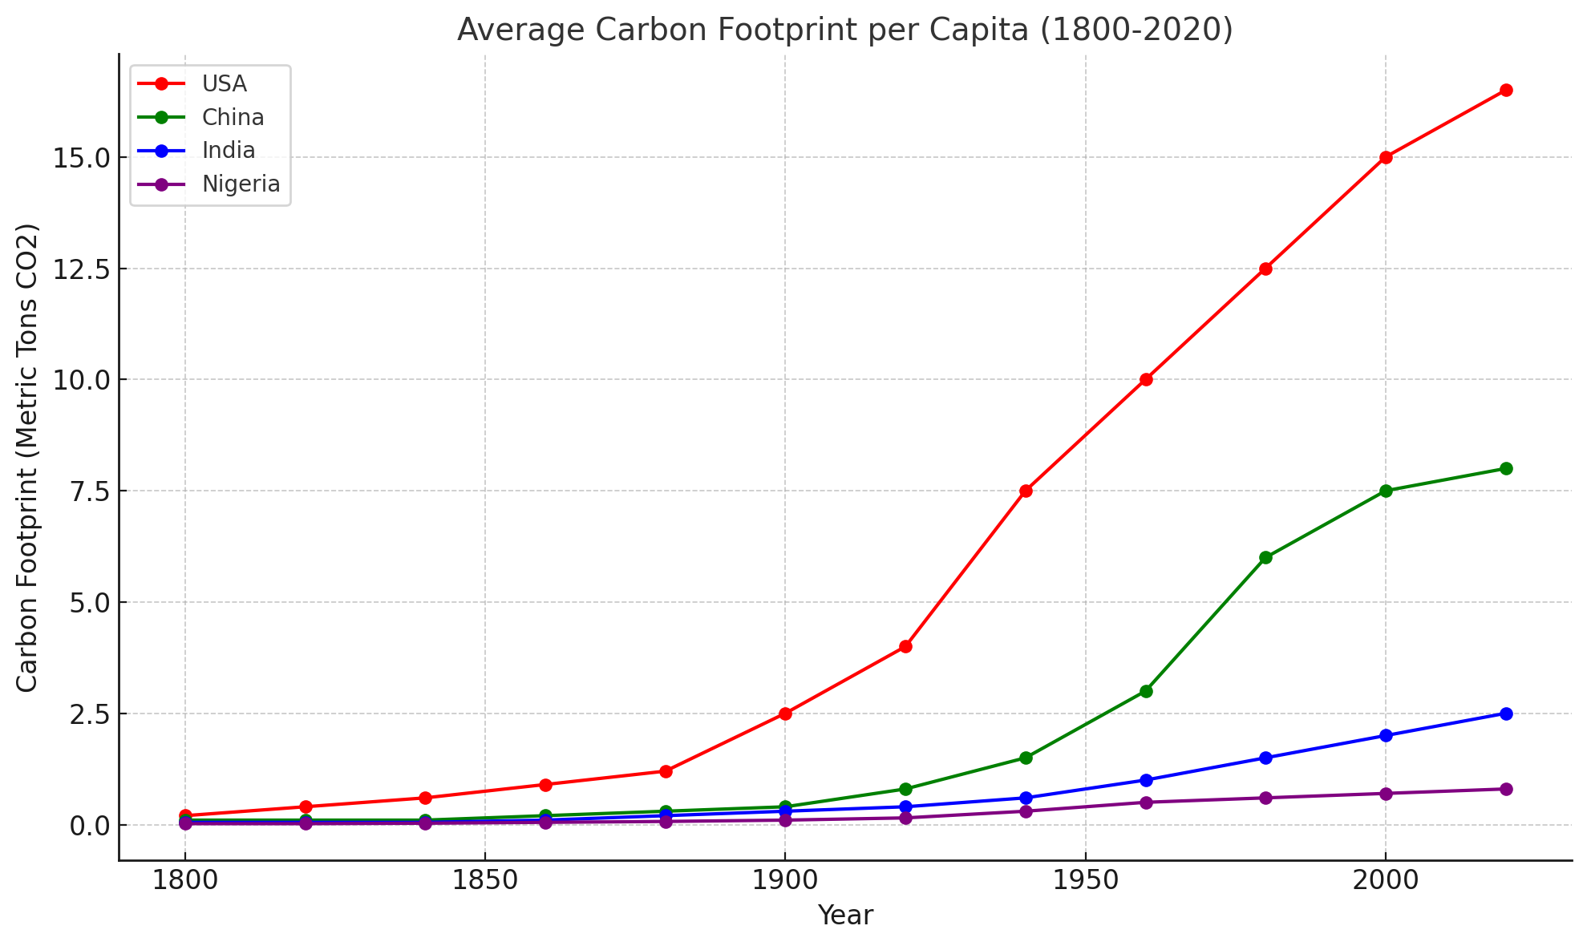

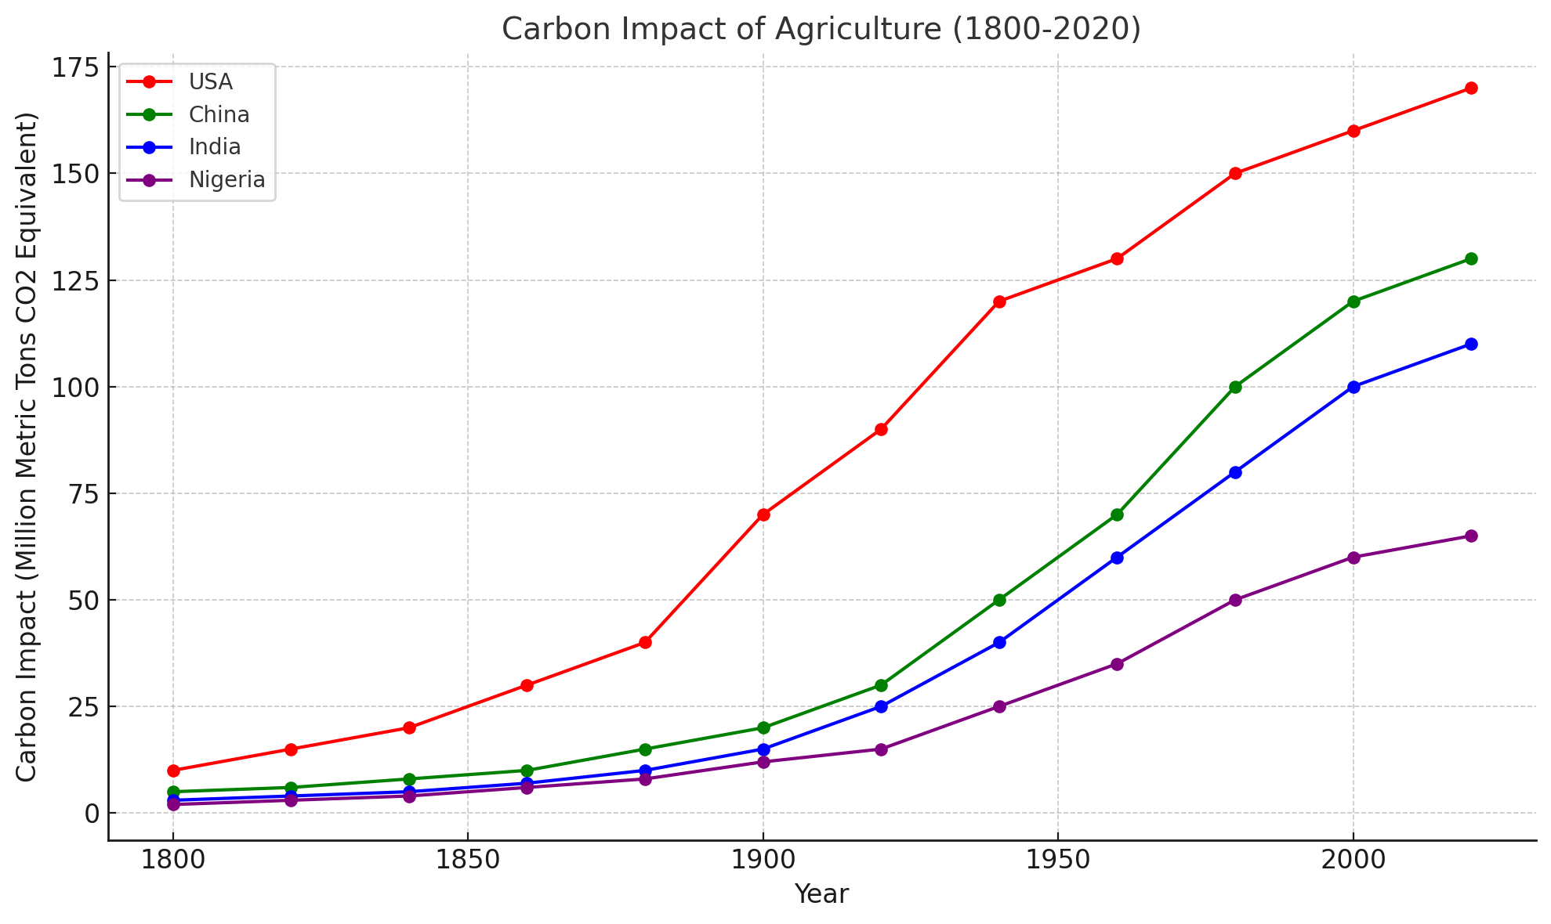

# 

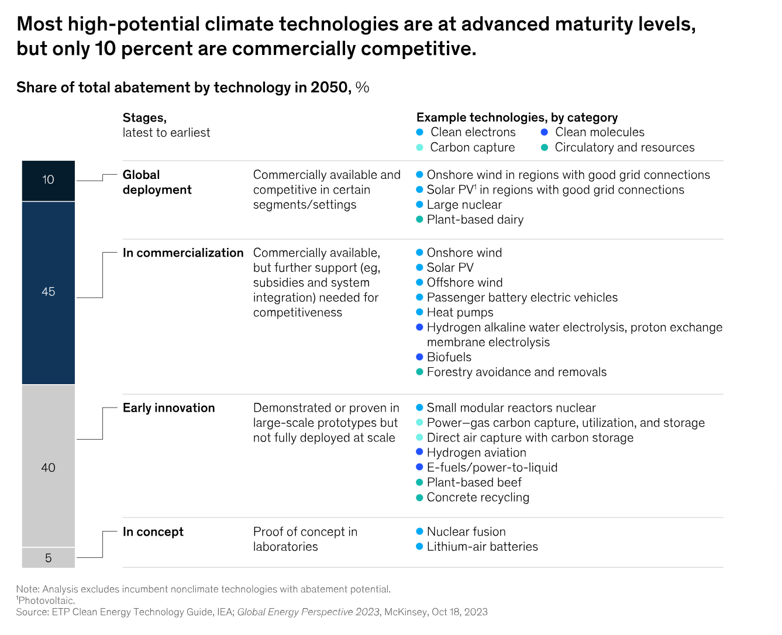

Could this be hand drawn a la Scott Galloway – make these very shareable (cut and paste)

Look at Bill Gates book diagrams – simple and compelling